Justin Peyser’s Sanctuary
By Matthew Teti
April 2023

Justin Peyser’s recent outdoor sculptural installation, Sanctuary (2022), cannot necessarily be described as a labyrinth, per se, but certainly as labyrinthine. Following his post-minimalist forbears into the territory of phenomenal installation, Peyser creates an open-ended, interactive space that beckons the mobile, sensate body of the viewer into its latticework. Sanctuary is composed of 14 cedar columns, ranging in height between 4 and 8 feet, which stand upright on a concrete pad, currently installed at the edge of a woodland preserve in Long Island, New York. These piers are penetrated somewhat randomly by molded metal protuberances. The latter are weighty or heavy looking—one resembling an oversize nail—and sign-like, but without referent. Exposure to the elements has already produced a ruddy patina on them, whose rusty connotations add insult to the presumed injury these protrusions threaten to perpetrate upon the participant-viewer. They jut out of the massive cedar beams like shrapnel scattered by an explosion. When one enters the space between the columns, they poke and prod the body, affecting movement and defining the sensation of being inside; something akin to running the gauntlet. Or, being lost in the Minotaur’s maze.

The labyrinth as an architectural structure originated in the Cretan myth of the artist and craftsman Dedalus, who created an inextricable prison for the Minotaur in King Minos’s palace. Labyrinthine structures were rumored to exist in ancient Greece and Egypt, and descriptions of, as well as plans for labyrinths were known in the Middle Ages, though three-dimensional labyrinths were uncommon and related most often to fantastic historic or mythological buildings in the old world. Up to the Renaissance, all labyrinths, whether three-dimensional or graphic, were unicursal—a single, un-branched, circuitous route leading inevitably towards a center point, although there is ample reason to believe, in accordance with the myth of Dedalus and the Minotaur, that early, undocumented, labyrinthine structures were what are commonly called mazes, which offer numerous courses to follow and a high permutation of potential journeys to the center. When they were built, rather than represented in manuscripts or on the floor of cathedrals, medieval labyrinths took the form of garden buildings, pergola-covered paths, hedge mazes, and turf mazes. Multicursal labyrinths baffled Renaissance participants—used to one true way in and out again—who recounted being disoriented, confused, angry, and physically and emotionally taxed by the experience of entering the labyrinth. For one thing, the tall walls of a European hedge maze deprive our sight of the horizon, which is one of the most critical markers of orientation, and thus there is a quality of sensory deprivation to the garden-variety labyrinth. Furthermore, navigating mazes involves disorienting repetition and doubling back, as the participant traces and retraces paths in a search for the ordained route. Such circumstances can cause the heart to race, as our Renaissance interlocutors observed, and feelings of overstimulation, disequilibrium, anxiety, and fatigue are some of the consequences of a trip into the labyrinth, whether uni- or multicursal.

On the most rudimentary level, Sanctuary’s current installation in the landscape, as well as that of many a post-minimalist earthwork, conjures up the garden maze or labyrinth for its formal, social, and metaphorical similarities—there’s no better comparison here than Robert Smithson’s Spiral Jetty (1970). But Sanctuary also resembles a maze or labyrinth in the high number of permutations through which one might navigate the sculpture. In a mimetic response to its surroundings, Sanctuary’s uprights invite participants to enter its surround as randomly as one might venture into the forest. Each approach to Sanctuary, like each excursion into the woods, is chosen in the moment, a function of the participant’s height, weight, level of mobility, state of distraction, orientation, and proclivities, among other factors. There may technically be a limited number of potential ways to enter the labyrinthine space, but the possibilities appropriately appear infinite, in keeping with the eternally beguiling nature of Dedalus’s construction. After spending a half an hour with Sanctuary, I never ventured inside the same way twice, nor did I follow the same route, once I was within the uprights. Each trip into the work was a distinct experience. When inside, looking out, the sculpture also changes the participant’s view of the landscape, and each dérrive—to borrow a term from the Situationists—yields a unique perspective on one’s environment. Just as Sanctuary looks to be configured differently from each exterior angle of approach, it flips the script and starts to alter one’s perception of the “outside” world instantly upon entry. In the minimalist sense, it is a thing to sense in a tactile fashion, as a circulating participant engulfed in its web, but it is also a thing to see from a distance, and then, finally, a thing to see through or past, once one is within its embrace.

The early association of labyrinths with the mythic building constructed by Dedalus was preserved in the Middle Ages, when, in France, they were referred to it as a dédale or maison dédalus. The architectural paradigm of which the labyrinth is an emblematic structure is also referenced in the common practice of naming labyrinths simply “Troy,” or by the name of another foundational Western city, like Jerusalem or Babylon. The medieval labyrinth was thusly linked to the idea of the archetypal city as a symbol of civilization—which kept the monstrous hybrid Minotaur at bay—a practice dating back to Roman tradition. The complexity of the labyrinthine design is both a metaphor for the intricacy of the city’s urban fabric, but also a testament to the architectural genius of builders (and by extrapolation, God). In medieval Europe, the labyrinth was viewed as a manifestation of and symbol for an architect’s masterful skill, which was celebrated in the pavement labyrinths of certain High Gothic cathedrals. The intention of Church labyrinths was in part to recreate or fashion in microcosm the procession of the pilgrim, which could be said to start from and return always to the cathedral pavement, sometimes placed above the crypt and in proximity to the altar, a pride of place in the hierarchical program of the Gothic. And it undoubtedly was pilgrims who, in the Christian kingdoms of England and France, commonly walked or danced the cathedral labyrinths at Church festival times, especially during Carnival and Easter celebrations.

In the sense of welcoming pilgrims, Sanctuary, whose title makes explicit reference to this function, is conceived in the spirit of a Church or other holy building, within whose walls people far and wide have long sought asylum. Here, Peyser is reacting to the ongoing migration crisis in the Mediterranean, and especially the artist’s adopted home, Italy. As in past work on the subject, Peyser is admirably concerned for the plight of diasporan subjects who face perilous passages to places that are hostile to their presence. Peyser speaks of diaspora as a “feeling of limbo,” but also as a “process of getting lost,” or state of “lostness.” Somewhat like a wanderer in a maze, but closer to a Minotaur incarcerated in a labyrinth, the diasporan subject loses their bearing, to paraphrase Peyser, and risks succumbing to the beguiling space, like the one encountered inside Sanctuary. While Peyser’s sculpture is profoundly open and beckoning, on the one hand, the barbed protrusions within simulate the exterior forces that cause migrants and other threatened classes to seek sanctuary. They too represent the Minotaur in Peyser’s maze—as threat activated—and they beg the question, how much sanctuary is there to be found? Or, under what conditions can sanctuary be helpful, rather than simply reinforcing hurt?

For the French theorist and dissident Surrealist, Georges Bataille, the great cathedrals of northern France and other monuments of Western civilization were not great edifices, but rather symbols of “society’s real nature—that of authoritative command and prohibition.” He wrote,

Thus great monuments rise up like dams, opposing a logic of majesty and authority to all unquiet elements; it is in the form of cathedrals and palaces that church and state speak and impose silence upon the crowds. Indeed, monuments obviously inspire good social behavior and often even genuine fear.

Critical theorist Denis Hollier has written that, for Bataille, architecture is “the system of systems. The keystone of systematicity in general,” indicating its use as a sign for all structures, both built and, moreover, ideological. In his book Against Architecture, Hollier argues, “man’s revolt against prison [architecture] is a rebellion against his own form, against the human figure. [...] the only way for man to escape the architectural chain gang is to escape his form.” Hollier draws on the tradition, at least as old as Vitruvius, of equating the human form and architecture, by way of emphasizing the far-reaching significance and centrality of the architectural metaphor in Bataille’s thinking. Deforming the human body is thus akin to knocking off edifices. In his Critical Dictionary entry “Architecture” from Documents, Bataille goes so far as to say that architecture is an attack on man, and he proposes the labyrinth as an escape route: “a path—traced by the painters—opens up toward a bestial monstrosity, as if there were no other way of escaping the architectural straitjacket.” Therefore, if Peyser’s Sanctuary is evocative of both a capital-C Church (Bataille’s emblem of architecture as overarching mechanisms of control—albeit a welcoming and rejuvenating space, in this case) and a labyrinth, the experience of which is harsh, prickly, and disorienting, then it would appear to be a sublimation of these seeming antagonisms; a third way, which we could say is the post-structural resolution of the deconstruction inaugurated in Bataille’s thinking.
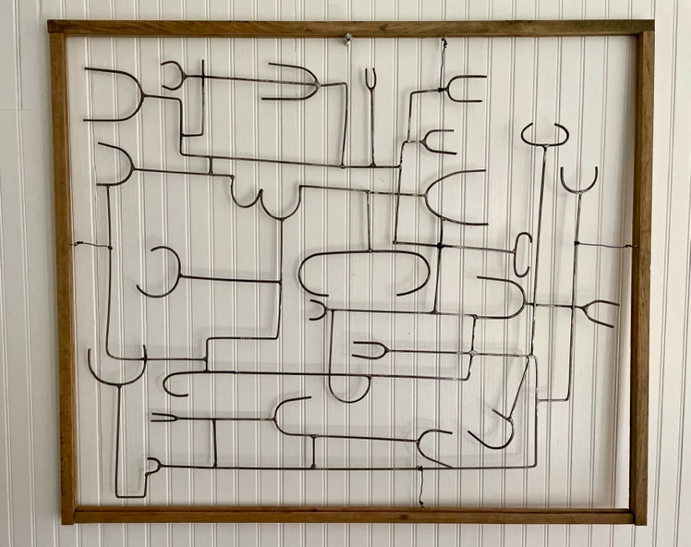

For a former member of the Community Preservation Corporation, we could also say that Peyser’s work is inflected with a latent city planning, especially his relief sculpture. In addition to appearing maze-like, wall-based works such as the one pictured above call to mind ariel views of a landscape marked by rectilinear, human interventions. In this study for Sanctuary, many of the symbols found in the metal pieces make an appearance in a map-like composition that is clearly a cityscape, subdivided by the vertical slats in the studio wall, framed by the piece. From this point, to Sanctuary, Peyser sheds the “architectural straitjacket” with which his work has long negotiated, while retaining a fundamental idea of architecture in the form of the labyrinth, which is not a practical building (except for its use as a prison for the Minotaur), but rather an irrational space.

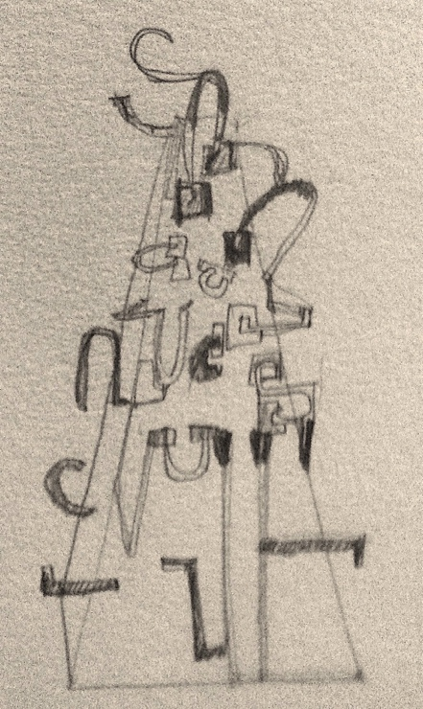

In a sketch for Sanctuary, Peyser attempts to map such an irrational space, which he barely seems to get his pencil around. Like a phantasmagoric maze, these walls appear to be capable of changing position at random, in a menacing fashion that would stymie rational progress. The recession of the form suggests a path into space, at least for the eye, but like Sanctuary it is barbed; more of a gauntlet than a hedge maze.

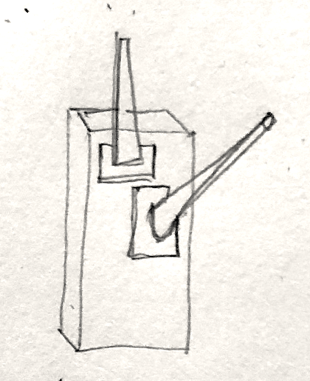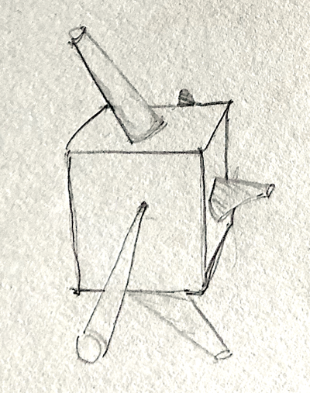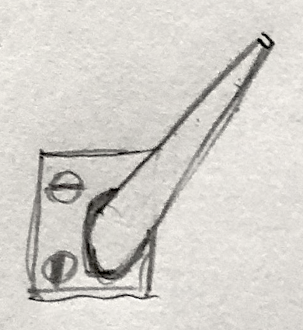

Some of the other drawings related to Sanctuary look themselves like torture devices, or even weaponry, albeit of a distinctly medieval sort. The sketch in the center’s square shape and profusion of barbs resembles a mace that might have been wielded by some mythic figure—perhaps someone who, once upon a time, intended to spare with the Minotaur. If you focus on the phallic signs in this selection, they also resemble the paranoid repetition compulsion at the heart of Yayoi Kusama’s famous “Accumulations” (early–mid 1960s). Indeed, they reinforce the threatening character of the protrusions of Sanctuary. Eros and Thanatos were similarly at the core of Bataille’s theory of the formless, referenced above, one of whose most potent symbols is the ithyphallic bird-man figure painted in the enigmatic pit mural at the caves of Lascaux, France ca. 20,000 B.P. This rudimentary human lays roughly horizontally at the feet of a great bison and, although presumably deceased, the man’s erection stands at attention, creating a 90-degree angle with his corpse. Another barb—the slain hunter’s pique—has fallen beneath the furry mammal, whose abdomen it has pierced and spilled the contents.

Just as Bataille’s concern over the soul-crushing character of architecture—its propensity to deform the human body—was for the human actors who inhabit the built environment, Peyser has long dwelled upon distorted anthropomorphs in his work, to such a degree that if he is a modernist, Peyser is, in my reasoning, a Surrealist. Over more than a decade, Peyser’s sculpture has continuously taken the shape of humanoid figures, common to modernism, often a hybrid creation with machine parts, animal attributes, and aesthetically simplified shapes, disfigured but still recognizable as vertically oriented and approximately symmetrical, just like the human body. Most notably, Peyser created a field of figures in the form of his first major public installation, Alla Deriva (Adrift, 2010), which is currently installed in a park in Rende, a university town in Calabria. The ten welded sculptures that make up Alla Deriva have been described as “headless and limbless,” “metal figures,” more human than human, in that they aesthetically conjure the history of Venice, where they were first installed as a group of maritime diasporans at the Armenian Cultural Center’s baroque Ca’ Zenobio palace in 2010. They are thus travelers across time and space, who prefigure the diasporan subjects Peyser had in mind when he started work on Sanctuary.

While not strongly figurative, the individual sculptures of the Alla Deriva group are roughly the height of an adult human, and they have a basic symmetry and uprightness that emulate the natural order, without having clearly identifiable body parts. Like good minimalist sculpture, their presence makes the viewer hyper aware of their own place in the space they inhabit. As in Sanctuary, being amidst the Alla Deriva installation is to be changed by it and to feel that one has entered a space outside of daily life. It is a rarified experience. It is also more open and less enclosing than the more architectural Sanctuary, particularly when installed outside, as it is currently. However, at the Ca’ Zenobio, Alla Deriva was placed in the great Hall of Mirrors, which features a mythological mural program, partially painted by Tiepolo, and elaborate sculptural decorations. The gigantic mirrors and the painted walls and ceiling of the Hall instilled Peyser’s installation with what one writer likened to a game with “an air of madness, the absurd,” feelings not dissimilar from those people experience in the labyrinth. The Hall of Mirrors’s rudimentary illusion involves reflections that distort one’s spatial awareness, and thus it is a form of sensory limitation commonly employed carnival attractions and by post-minimalist installation artists, like Yayoi Kusama and Lucas Samaras.

As previously mentioned, Sanctuary responds to the landscape in a mimetic, formalist manner that is new in Peyser’s work to date. Installed on the edge of the forest in Long Island, the cedar beams’ uprightness reflects the surrounding trees, many of which are the same cedars that lend this region its signature shingled architecture. Chosen as a building material for its durability and resistance to rot, cedar shingles nonetheless weather and wear with age. Like Sanctuary’s columns, cedar shingles are an auburn hue when they are introduced to the elements, but gray over time in a natural process of decomposition. Like a fallen cedar a few yards from where the sculpture is currently installed, the cedars of Sanctuary already evidence the ravages of time. However, their sheer mass, like the trunks of the trees in the landscape, will distend their degradation, such that they show atmospheric effects only on their surface, much like the homes that cedar shingles preserve. By using a material normally chosen for an exterior architectural cladding as the building blocks of his installation, Peyser somewhat subverts cedar’s site-inflected medium specificity.

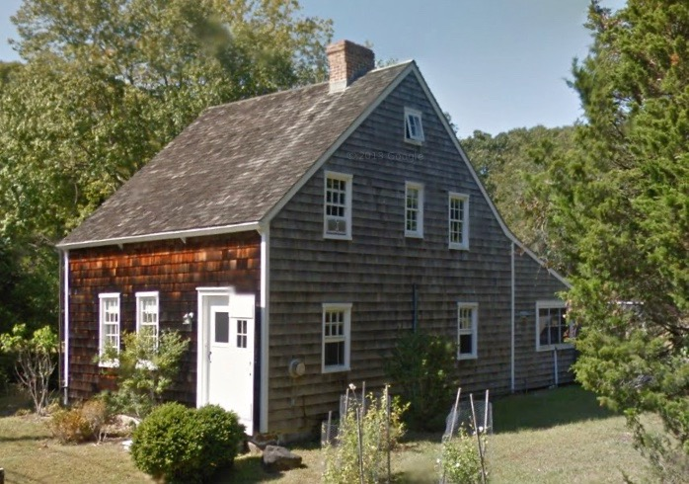Shingle style architecture

Some of Peyser’s other site-specific outdoor sculptures reflect their surroundings in a related fashion. Desert Schooner (2016), made for the Arizona desert, has the lateral expanse and roughly pyramidal shape of a mountain range, landscape, and an expansive horizon, not to mention the covered wagons for which the piece is named. Transportation is the logic of this work, which also features a rail line on a straight track running horizontally through it. Building on the allusion to migration in the title, Desert Schooner successor, the railroad refers, however unwittingly, to Manifest Destiny and expansionist policies during the “settling” of the United States. The railroad was what settlers went into the Southwest in order to install, cutting the steel trails that would bring their kind safely and ever deeper into Native American lands further West. Like much of Peyser’s work, the railroad also signifies migration’s great people-mover: trains. Whether its Jews, Roma, and other condemned souls being sent to concentration camps, or Black Americans rising up out of terror and apartheid in the American South to brighter futures up North and out West, the train is a paradigmatic tool of modern human migration. However, at a mere 7 cm deep, Desert Schooner is a space-painting with an essentially 2D aesthetic approach to the landscape, which works in the southwest, where the horizon is omnipresent in a way it is not in the forests of the American Northeast.

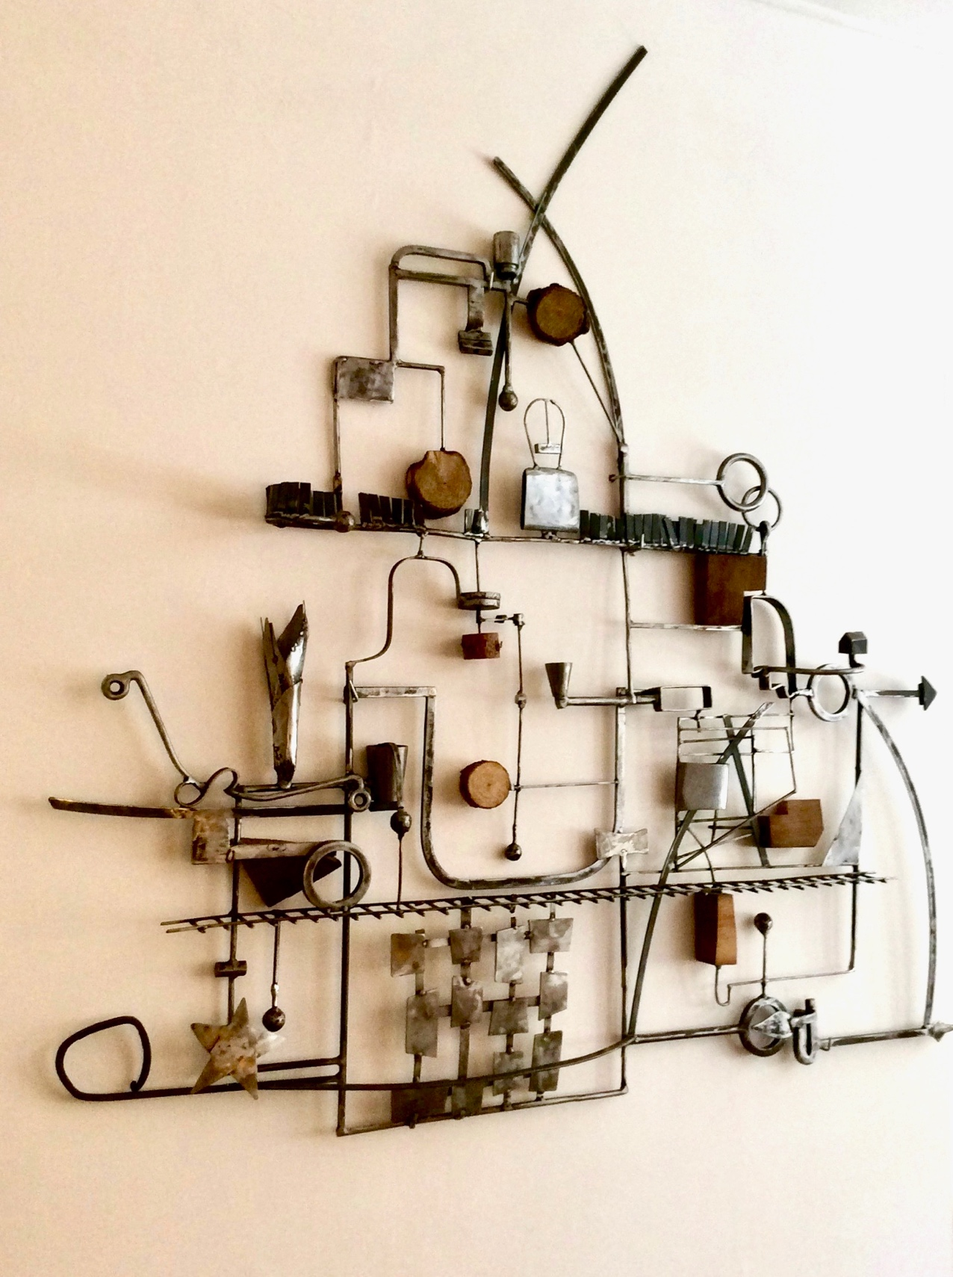
Desert Schooner

The interweaving of the two primal elements—wood and steel, not classically high in the rankings of sculptural mediums—has been a fixture of Peyser’s work of the last decade. Like Desert Schooner, the Inclusions (2014) are three-dimensional sculptures that privilege a two-dimensional point of view. They are, in fact, reliefs, in the traditional sense,]: wall-bound assemblages that ape the rectangular frame of a painting or drawing. In the Inclusions, raw wooden slices expose the whorls of the trees’ rings, which, with the roughness and irregularity of the bark, provides natural balance to an otherwise geometric and man-made, steel armature.

Inclusion 1

Another fruitful combination of mediums normally not placed in concert can be found in a sculpture that Peyer intends to be public: a bench commissioned along with an international cadre of artists, including Gio Pomodoro, Joe Tilson, Jean Paul Phillipe, Kan Yasuda, and Matthew Spender, for a small-town square outside of Siena. Sculpting with locally sourced travertine from the quarries of Serre di Rapolano (Siena), Peyser’s bifurcated bench is like puzzle blocks that interlock and straddle a rectangular steel frame, the size and shape of which recalls legendary minimalist works, such as Tony Smith’s Die (1962). In keeping with its medium specificity, the travertine has rounded, as well as hard edges, and is polished, in distinction to weathered quality of the steel surround. Once again, the steel frame establishes a two-dimensionality to the sculpted form, but here the protrusion of the benches into the third dimension, in tandem with their invitation to sit—and not only to sit, but to commune—breaks into the z-plane in a way in which the Inclusions, for instance, do not. As a public bench, the piece would be naturally accommodating in the same way in which it is easy to be lured into the interion of Sanctuary. Both sculptures are enclosures that are at the same time profoundly open.

Hermann Kern, Through the Labyrinth: Designs and Meanings over 5,000 Years (Munich: Prestel, 2000), p. 23; Penelope Reed Doob, The Idea of the Labyrinth from Classical Antiquity through the Middle Ages (Ithaca, NY: Cornell University Press, 1990), pp. 18–19, 40.
Doob, The Idea of the Labyrinth, p. 110.
W.H. Matthews, Mazes and Labyrinths: A General Account of Their History and Development (London: Longmans, Green, and Co., 1922), p. 60; Kern, Through the Labyrinth, p. 247; Doob, The Idea of the Labyrinth, p. 107.
Matthews, Mazes and Labyrinths, p. 60; Kern, “Labyrinths,” p. 62; Doob, The Idea of the Labyrinth, pp. 115–117.
Matthews, Mazes and Labyrinths, pp. 61, 111; Doob, The Idea of the Labyrinth, pp. 121–123.
Doob, The Idea of the Labyrinth, pp. 113–114, 123–127.
Justin Peyser, personal communication, April 2023.
Georges Bataille, “Architecture” (1929), trans. Dominic Faccini, October 60 (1992), p. 25.
Denis Hollier, Against Architecture: The Writings of George Bataille, trans. Betsy Wing (Cambridge, MA: The MIT Press, 1989), p. xii.
Bataille, “Architecture,” pp. 25–26.
Teddy Jefferson, “Ten Figures for Ca’ Zenobio by Justin Peyser,” in Justin Peyser: alla deriva, edited by Teddy Jefferson (Venice: Ca’ Zenobio, 2010), pp. 18, 24.
Jefferson, “Ten Figures,” p. 31.

